­



**SCHOOL OF COMPUTING AND INFORMATICS**

**CCC1123**

**Problem-Solving and Programming Fundamentals**

**Lecturer: Dr. Muhammad Amin Sahari**

|  |  |
| --- | --- |
| **NAME:** | **Md Farman Ali** |
| **STUDENT ID:** | **AIU20092185** |

**Math Calculator Project**

**INDIVIDUAL ASSIGNMENT (20%)**

**_______________________________________________________________________**

**For Examiner’s use only**

|  |  |  |  |  |
| --- | --- | --- | --- | --- |
| **MARKS** |  |  |  |  |
| **TOTAL (20)** |  | | | |

**Submission Date:6/11/2023**

**Here is a math calculator project (main.c) file:**

#include <stdio.h>

int main() {

char name[50];

double num1, num2;

printf("Hi! Welcome to Math Calculator.\n");

printf("Please enter your name: ");

scanf(" %[^\n]", name);

printf("\nHello %s! Welcome to Math Calculator.\n\n", name);

printf("To begin, please enter two numbers.\n");

printf("First number: ");

scanf("%lf", &num1);

printf("Second number: ");

scanf("%lf", &num2);

printf("\nYou have entered %.2lf and %.2lf.\n\n", num1, num2);

double addition = num1 + num2;

double subtraction = num1 - num2;

double multiplication = num1 * num2;

double division;

if (num2 != 0) {

division = num1 / num2;

}

printf("The addition of %.2lf and %.2lf is equal to %.2lf.\n", num1, num2, addition);

printf("The subtraction of %.2lf and %.2lf is equal to %.2lf.\n", num1, num2, subtraction);

printf("The multiplication of %.2lf and %.2lf is equal to %.2lf.\n", num1, num2, multiplication);

if (num2 != 0) {

printf("The division of %.2lf and %.2lf is equal to %.2lf.\n", num1, num2, division);

} else {

printf("Cannot perform division. The second number is zero.\n");

}

printf("\nThank you for using Math Calculator!\n");

return 0;

}

**Title:**

**Math Calculator Project Report**

**Introduction:** I am Briefly explaining the purpose and objectives of the project below: The purpose of this project is to use the C programming language to develop a math calculator. The goal is to create a program that enables users to add, subtract, multiply, and divide two input integers using simple mathematical operations. The user is requested to enter their name and two digits into the user-friendly interface of the Math Calculator program. After receiving the input, the program then executes the required mathematical operations and shows the user the results.

A program is a useful tool for making rapid calculations without the use of external calculators or complicated mathematical procedures. It gives users an easy way to quickly get the sum, difference, product, and quotient of two integers, enabling them to easily solve mathematical issues or carry out simple arithmetic operations. The Math Calculator program adopts a simple methodology, accepting user input, carrying out the calculations, and showing the results in a structured and understandable way. It aspires to be user-friendly and intuitive, serving users who need a straightforward but effective tool for carrying out fundamental mathematical operations.

**Overview**: In the following sections of this report, I will delve into the design and implementation details of the Math Calculator program, provide a code listing, showcase the program's functionality through screenshots, discuss the testing process, and present the results obtained.

**Program Design and Implementation:** The structure and logical flow of the Math Calculator program are intended to be straightforward. The user is requested for input, the computations are run, and the results are shown in a sequential execution paradigm.

1. **User Input:** ­­­

* The program starts by displaying a welcome message and requesting the user's name.
* The user's name is obtained using the scanf function and stored in the name variable.
* Next, the program prompts the user to enter two numbers.
* The numbers are obtained using the scanf function and stored in the variables num1 and num2.

1. **Mathematical Operations:**

* The program performs the following mathematical operations on the input numbers: addition, subtraction, multiplication, and division.
* Four variables are used to store the results of each operation: addition, subtraction, multiplication, and division.
* The calculations are performed using the basic arithmetic operators (+, -, *, /).

1. **Displaying Results:**

* The program uses the printf function to display the results to the user.
* The calculated values, along with the input numbers, are displayed in a formatted manner.
* The printf statements are used to print messages that inform the user about the performed operations and their results.
* The program's structure is linear, progressing from requesting user input to carrying out calculations and showing the outcomes. Basic arithmetic operations and the input/output methods offered by the C programming language are used to create the logic.
* The program's structure is linear, progressing from requesting user input to carrying out calculations and showing the outcomes. Basic arithmetic operations and the input/output methods offered by the C programming language are used to create the logic.
* The Math Calculator program offers a user-friendly experience by adhering to this structure and logic, enabling users to enter their names and numbers, conduct many mathematical operations, and examine the results in a straightforward and structured way.

**Screenshots: Code Listing:**

**Step 1:** Here is the main code of the project using Visual Studio(VS):

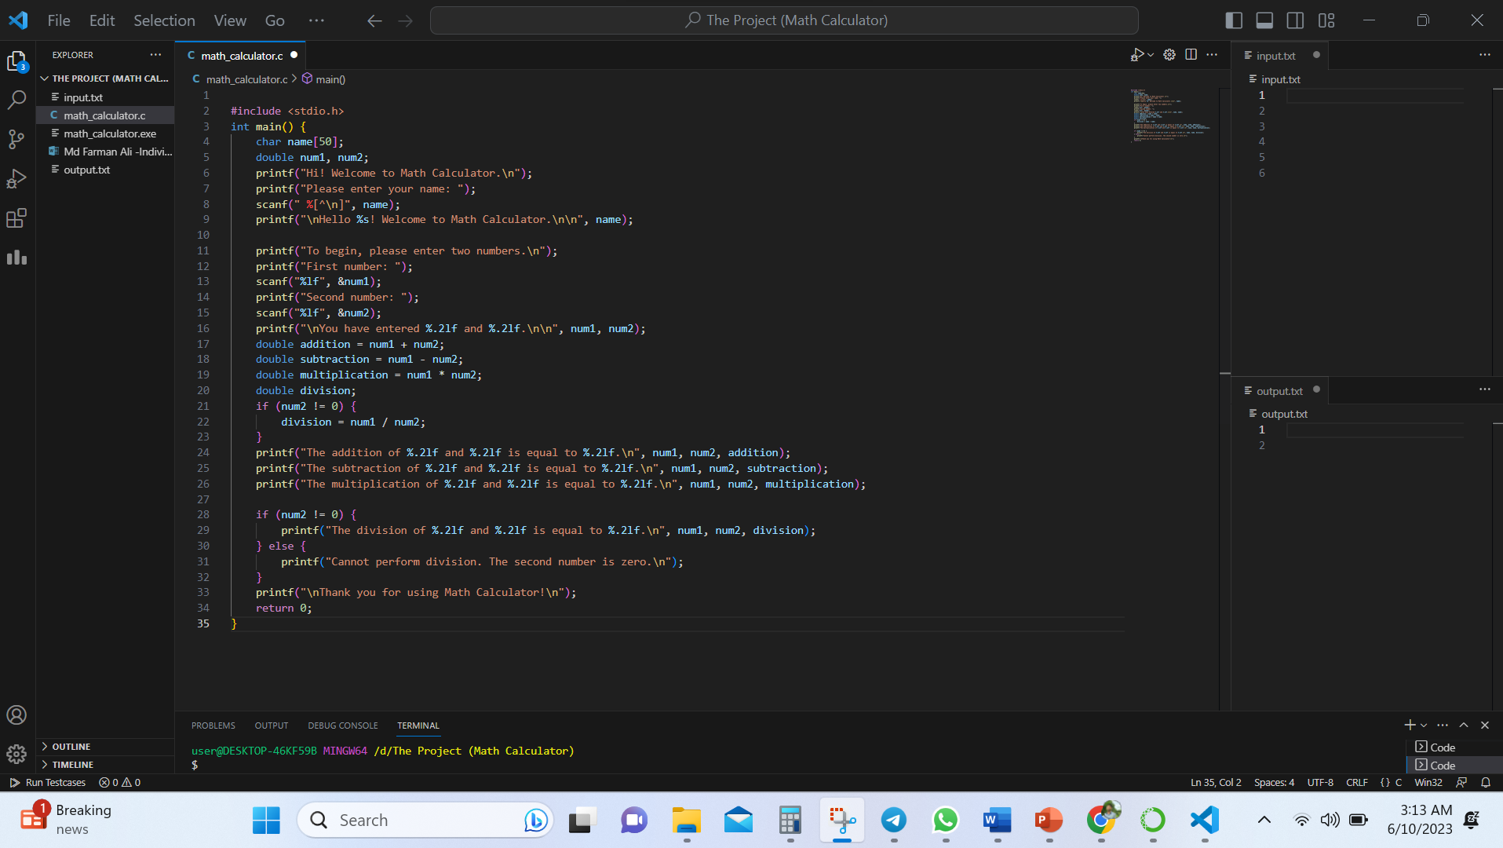

**Step 2:** Ask the user for the give Full Name in the input:

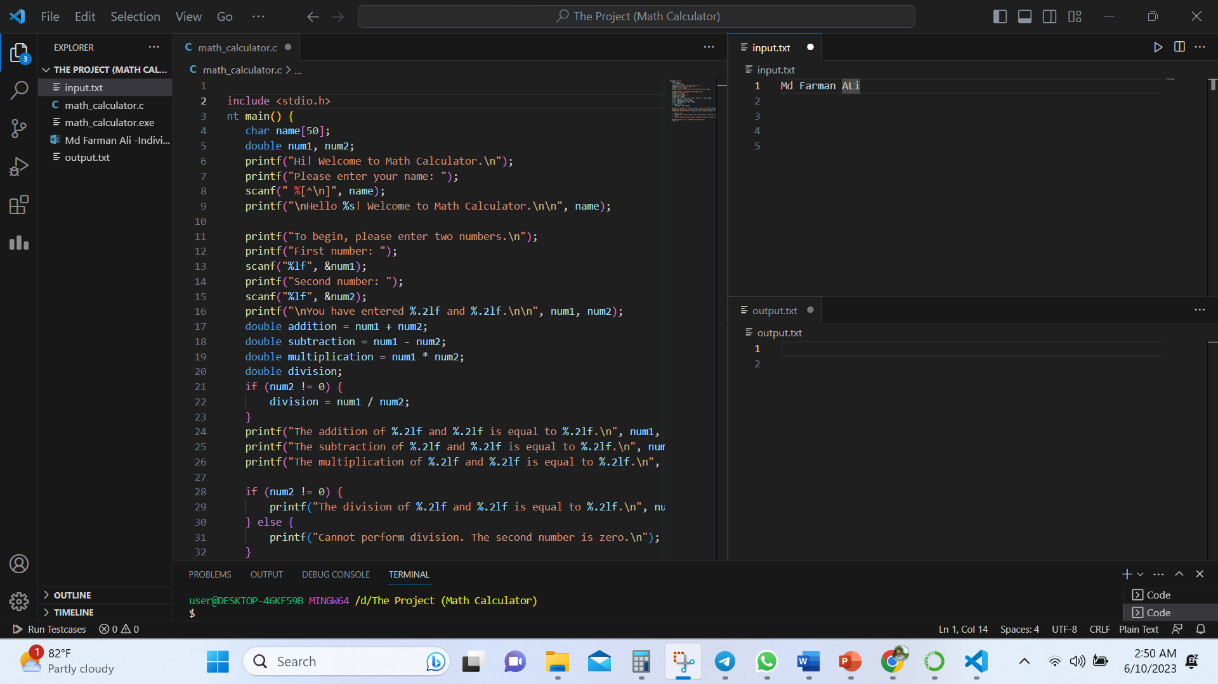

**Step 3:** Ask the user the First and Second numbers needed.

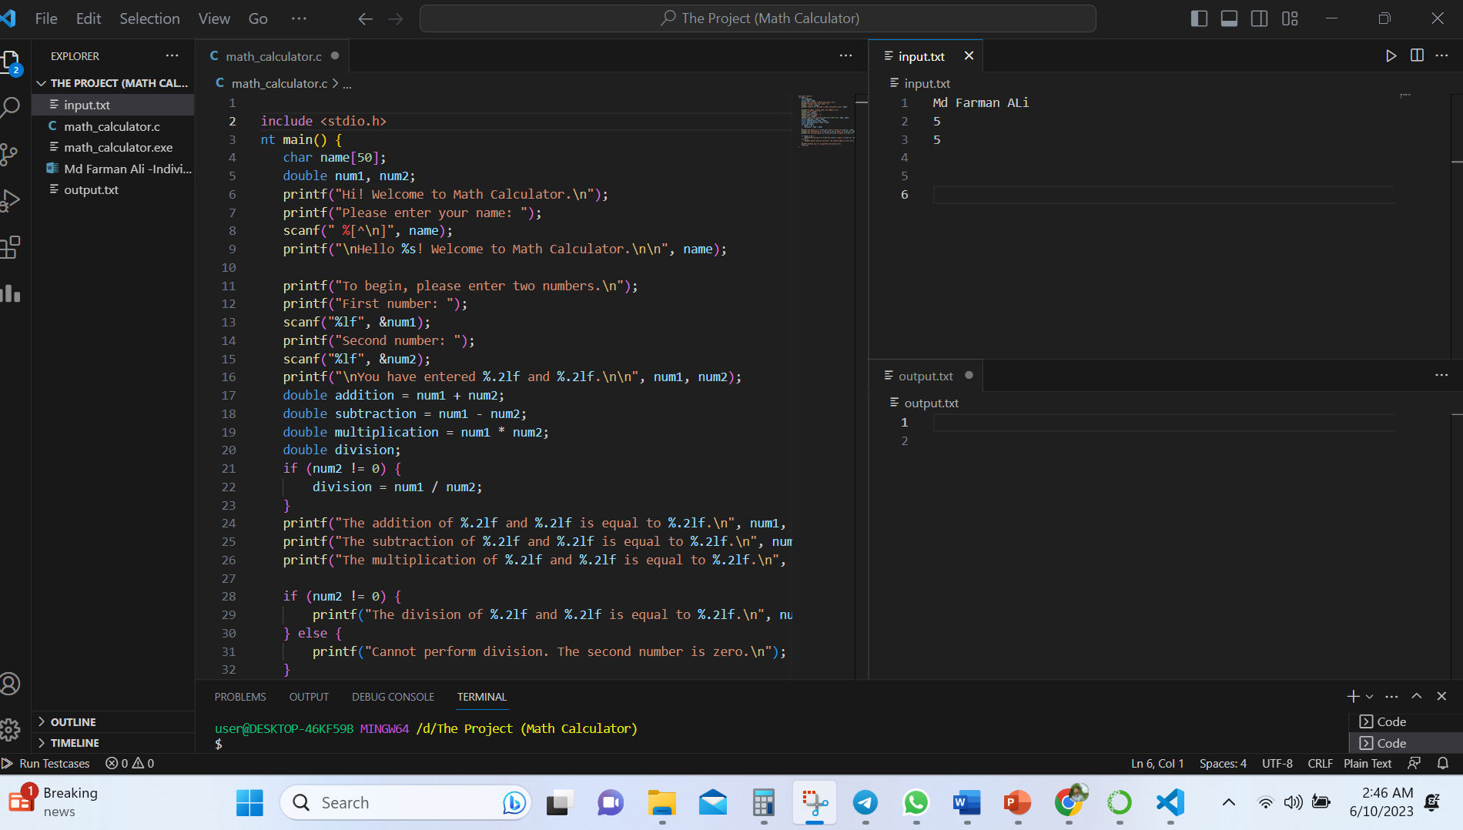

**Testing and Results:** **Step 4:** Here is a final result

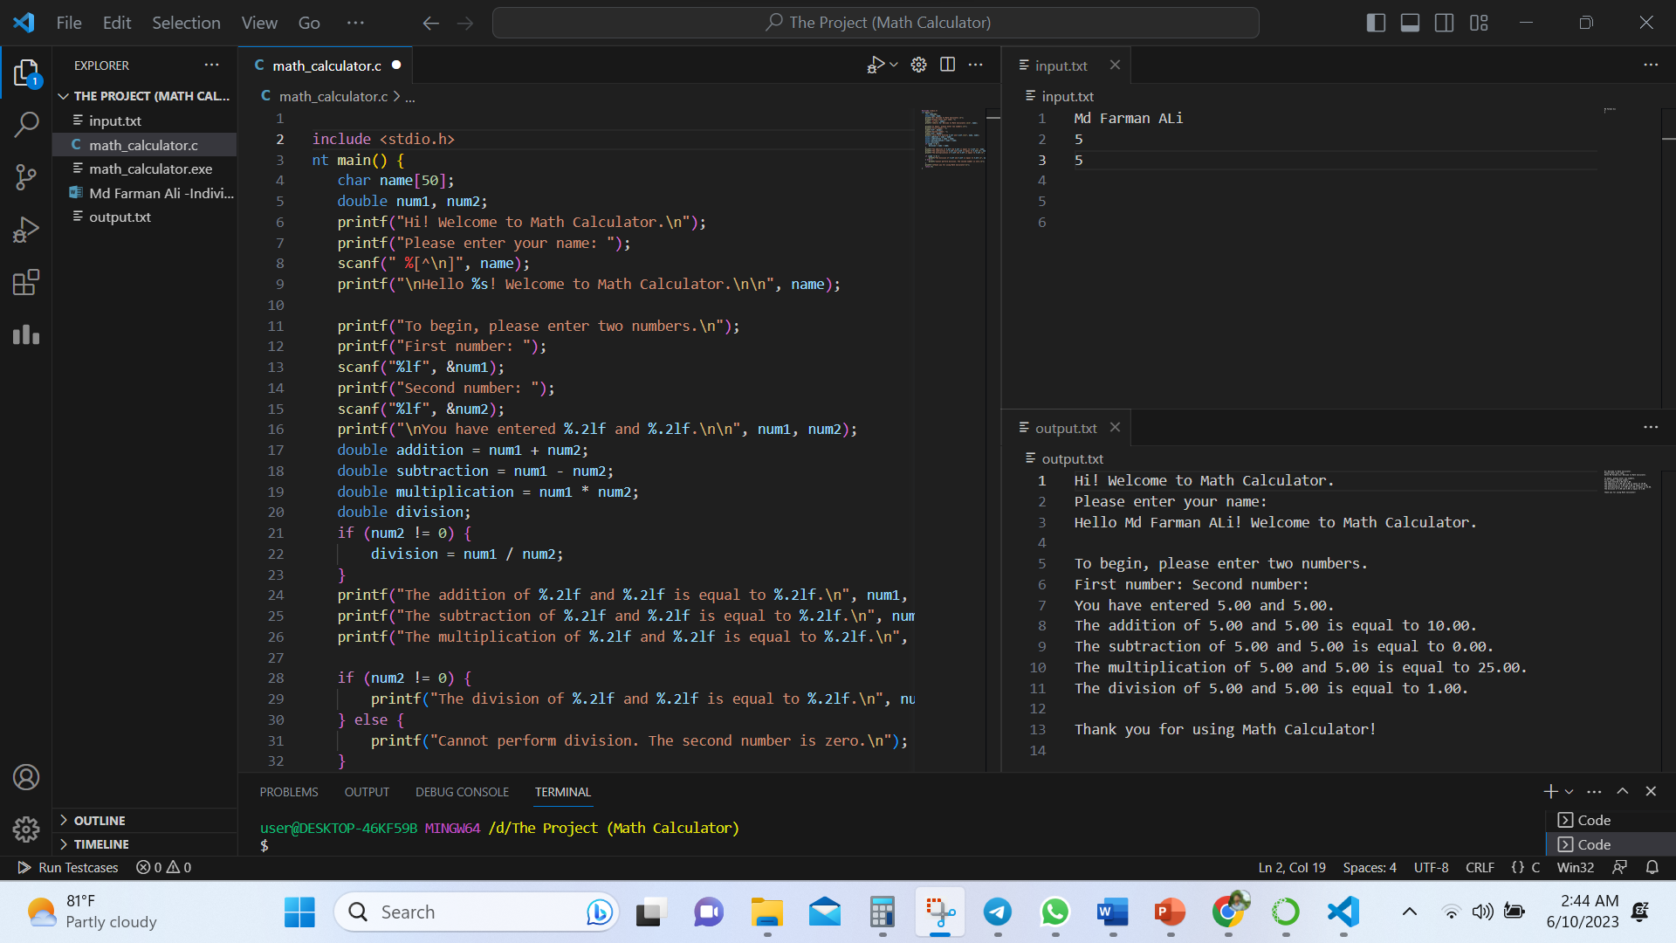

**Discussion:**

Several challenges and difficulties were encountered during the project, as well as design decisions and modifications made to the original requirements. Let's discuss them in detail:

1. **User Input Validation:**

* Challenge: Validating user input was one of the problems that had to be overcome. Since the two numbers must be inputted numerically, it was required to address situations in which non-numeric values were entered.
* Solution: To solve this problem, extra input validation was put in place utilizing functions like is a digit or by verifying the return result of scanf. This made sure that the program elegantly handled unexpected input.

1. **Division by Zero:**

* Problem: Dividing by zero presented still another difficulty. It was crucial to address this extreme case since in mathematics, division by zero is undefinable.
* Solution: The problem was solved by adding a conditional statement that first checked to see if the second integer (denominator) was zero before dividing the numbers. An error message was shown in place of the division calculation if the denominator was zero.

1. **Decimal Precision:**

* Design Choice: To produce a consistent and understandable output, it was decided to use the printf statements.2f format specifier to display the results with a precision of two decimal places.

1. **Program Flow and User Experience:**

* Design Modification: A loop structure, such as a while loop, could be added to allow users to perform multiple calculations without exiting the program and running it again.

**Conclusion**: The Math Calculator project was successful in using C to develop a calculator program that is both practical and user-friendly. With capabilities like input validation and managing division by zero, it enables users to perform fundamental mathematical operations on two input integers. With regard to input handling, arithmetic operations, conditional statements, and output formatting, the project offered useful learning opportunities in C programming. Overall, the assignment was enlightening and reinforced important programming ideas and problem-solving techniques.

**References:** No external resources or references were used in the project. The program was implemented based on the knowledge and skills acquired during the learning process.

Thank You!